Explanatory document to Baltic CCR TSOs proposal in accordance with Article 41(1) of the Commission Regulation (EU) 2017/2195 of 23 November 2017 establishing a guideline on electricity balancing

Table of Contents
1. Definitions 4
2. Introduction 5
2.1. Background 5
2.2. The CZC studies 5
3. Formulating the CZC value forecast for the day-ahead market in the procurement optimization function 7
3.1. The day-ahead forecast proxy 7
3.1.1. Statistical approximation of the supply curves 7
3.1.2. Building the day-ahead forecast proxy 8
3.2. The procurement optimization function 10
4. Mathematical formulation of the Baltic balancing capacity optimisation algorithm 12
4.1. Allocation of CZC 12
4.2. Product balances 12
4.2.1. The day-ahead energy balance 12
4.2.2. The balancing capacity balance 12
4.2.3. The balancing capacity export restriction 13
5. CZC allocation determination 14
6. The maximum and optimal volume of allocated CZC for the exchange of balancing capacity or sharing of reserves 15
7. Impact of allocating large shares of CZC for balancing capacity to neighbouring countries 18

- Definitions
BZ – Bidding zone
BZB – bidding zone border
CZC – Cross-zonal capacity

- Introduction
This document gives background information and the rationale for AST, Elering, Fingrid, Litgrid, Polskie Sieci Elektroenergetyczne and Svenska kraftnät proposal's for the amendment of methodology for a market-based allocation process of cross-zonal capacity (hereinafter referred to as “CZC”) for the exchange of balancing capacity in accordance with Article 41(1) of the Commission Regulation (EU) 2017/2195 of 23 November 2017 establishing a guideline on electricity balancing (hereinafter referred to as “EB GL”). This proposal is hereinafter referred to as the “Proposal”, and AST, Elering, Fingrid, Litgrid, Polskie Sieci Elektroenergetyczne and Svenska kraftnät are hereinafter collectively referred to as the “Baltic CCR TSOs”.

  - Background
The Baltic CCR TSOs envisage implementing a common balancing capacity market between the three Baltic countries in order to maximize economic efficiency and guarantee the necessary amount of reserves to be present at any given time for the Baltic countries. The balancing capacity market is envisaged to start by the time the Baltic countries connect their power systems to the Continental European Synchronous Area (CESA), which is scheduled to take place by the 1st of January 2026.
The Baltic countries’ balancing capacity needs are significantly high compared to their peak loads. The balancing capacity need would be approximately 1800 MW of upward FRR and 1500 MW of downward reserve to be procured for the three Baltic countries combined. Fulfilling such an FRR demand would be impossible with the fleet of power plants currently existing and expected to enter the market by 2026. Instead, the Baltic TSOs have drafted a plan for an extensive sharing of reserves scheme to be implemented such that a total of approximately 710 MW of upward and downward FRR capacity shall be procured and shared between the countries. This amount of FRR will be able to cover any largest reference incident in the Baltic countries. The vision relies on extensive use of CZC to allow all Baltic countries the access to the necessary amount of balancing capacity.

  - The CZC studies
The Baltic CCR TSOs have procured two studies which investigate the appropriate forecasting methodology for forecasting the market value of CZC for the exchange of energy; to investigate the appropriate maximum volumes of allocated CZC for the exchange of balancing capacity or sharing of reserves and the impact of allocating large volumes of CZC for the exchange of balancing capacity or sharing of reserves.
The first study (hereinafter referred to as the “CZC Study 1”), was conducted in 2021. The aim of the study was to propose an appropriate forecast methodology for the Baltic balancing capacity market. The specific challenges of the Baltic balancing capacity market are the high reserve demand for each Baltic bidding zone, an extensive amount of sharing of reserves and a high volume of CZC to be allocated for balancing capacity. Due to these reasons, a simple reference day method, which has been implemented in other CCRs is not suitable for the Baltic countries. As a results of CZC Study 1, a forecast methodology has been proposed which is based on a simple reference day approach, but which is accompanied by a bidding-zone based price-volume parameter that allows the forecast to be adjusted when the situation regarding the CZC is changed. The forecast methodology was found very suitable for the Baltic countries and is envisaged to be implemented along with the balancing capacity market. The description of the forecast methodology has been provided in this document, in section 2.
In 2022, another study (hereinafter referred to as the “CZC Study 2”), was conducted where consultants investigated the details regarding CZC allocation between the Baltic bidding zones. More precisely, after in-depth modelling of the Baltic balancing capacity market, the appropriate CZC allocation limitations where proposed, which were based on analyzed economic parameters and an analysis taking into account the aspects of balancing capacity security of supply. Furthermore, several impacts were analyzed: firstly the impact on neighbouring countries’ day-ahead markets of allocating large shares of CZC on the borders between the Baltic bidding zones and secondly the impact of significantly limiting the maximum CZC allocation for balancing capacity between the Baltic bidding zones. The results of CZC Study 2 have been described in sections 6, 7, and 8.

- Formulating the CZC value forecast for the day-ahead market in the procurement optimization function
The objective function of the procurement optimization function is the maximization of welfare across the day-ahead and the balancing capacity markets. In the Baltic CCR market-based CZC allocation methodology, the actual value of CZC for the exchange of balancing capacity or sharing of reserves and the forecasted market value of CZC for the exchange of energy shall be compared. The day-ahead market is represented via a forecast methodology which constructs a forecasted proxy of the day ahead market. The balancing capacity market is represented by the actual bids of the balancing capacity market. Therefore, in the procurement optimization function, the forecasted welfare for the day-ahead market is compared to the actual welfare of the balancing capacity market. The forecasted day-ahead market proxy model is constructed as described below.
  - The day-ahead forecast proxy
    - Statistical approximation of the supply curves
Often, simple reference day forecast methodology is used to forecast the CZC value for day-ahead market. In such a case, price difference of a similar day and similar hour is taken as the value of CZC for day-ahead market. The Baltic TSOs foresee possible need for allocating large shares of CZC for balancing capacity. For such a case, a simple reference day is not adequate to deliver a forecast of CZC, because large shifts in allocation of CZC can severely impact the value of CZC which the simple reference day methodology is unable to capture. Thus, it is necessary to represent the day-ahead market in a more realistic way.
Generally, the market welfare of a day-ahead market in a certain bidding zone can be expressed through the following formulation:
$$WF= \sum_{i}{q_{d,i}×p_{d,i}-\sum_{i}{q_{s,i}×p_{s,i}}}$$
Where:
i - the set of accepted demand and supply bids;
$q_{d,i}$ – quantity of demand bid i;
$p_{d,i}-$price of demand bid i;
$q_{s,i}$ - quantity of supply bid i;
$p_{s,i}$ - price of supply bid i.
The presented welfare formulation implies the knowledge about all supply and demand bid sizes and quantities. This information is not available at the time of allocating CZC for exchange of balancing capacity or sharing of reserves, and an approximation must be implemented. A significant gain in simplicity can be achieved when individual bids are replaced by a continuous supply curve, which determines the supply and demand values for a given clearing price. For the case of supply bids, such a simplification from individual bids to a linear approximation is presented as follows:
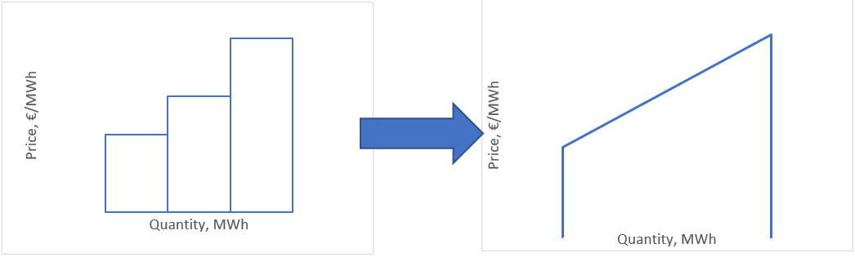
In the simplified case, a relationship between the output of the aggregate of suppliers in a bidding zone and the clearing price of the bidding zone is established. This can be called “the price-volume sensitivity” of a bidding zone, which can be calculated per bidding zone a by analyzing clearing data from a statistical sample of MTUs and calculated over average values:
$$α_{a}= \frac{∆p_{a}}{∆q_{a}}$$
The price-volume sensitivity $α_{a}$ allows to estimate the change in day-ahead market clearing price as a function of dispatched generation, which will be used in the following steps to establish a full day-ahead market welfare expression.
$${∆p_{a} =∆q_{a} ×α}_{a}$$

The simplified representation of the day-ahead market dispatch costs which uses the price-volume sensitivity parameter, shall in this document be named the day-ahead forecast proxy.
The day-ahead forecast proxy allows to approximate the price and volume interaction between several bidding zones and bidding zone borders. A simple example of such approximation between two bidding zones is illustrated below.

Example of price-volume sensitivity mechanic between two congested bidding zones

Bidding zone A forecast values:  Net position: +200 MW  DAM price: 40 €/MWh  $α$ = 0,04 €/MW | Bidding zone B forecast values:  Net position: -200 MW  DAM price: 50 €/MWh  $α$ = 0,08 €/MW

Forecast situation
NTC between BZ A and BZ B is 200 MW.

NTC: 200 MW
DA flow: 200 MW
Bidding zone B
Price = 50 €/MWh
Bidding zone A
Price = 40 €/MWh

Realized actual situation
Compared to the forecast situation, the NTC between A and B is reduced by 50 MW.

NTC: 150 MW
DA flow: 150 MW
Bidding zone A
Price = 40 – 0,04* 50 = 38 €/MWh

Bidding zone B
Price= 50 + 0,08*50 = 54 €/MWh

    - Building the day-ahead forecast proxy
In order to express the realistic price-volume interaction in the balancing capacity procurement optimization function, the price-volume parameter $α_{a}$ must be correctly determined. Without having access to the exact bidding curves in each bidding zone under consideration, the approximation must be made through long-term statistical analysis.
From a long-period statistical analysis the price-volume sensitivity parameter is determined by observing historic day-ahead market prices, as well as the output of dispatchable generation in the bidding zone.
An illustration of such a statistical sample along with the determine price-volume sensitivities for the three Baltic bidding zones has been presented in the image below.
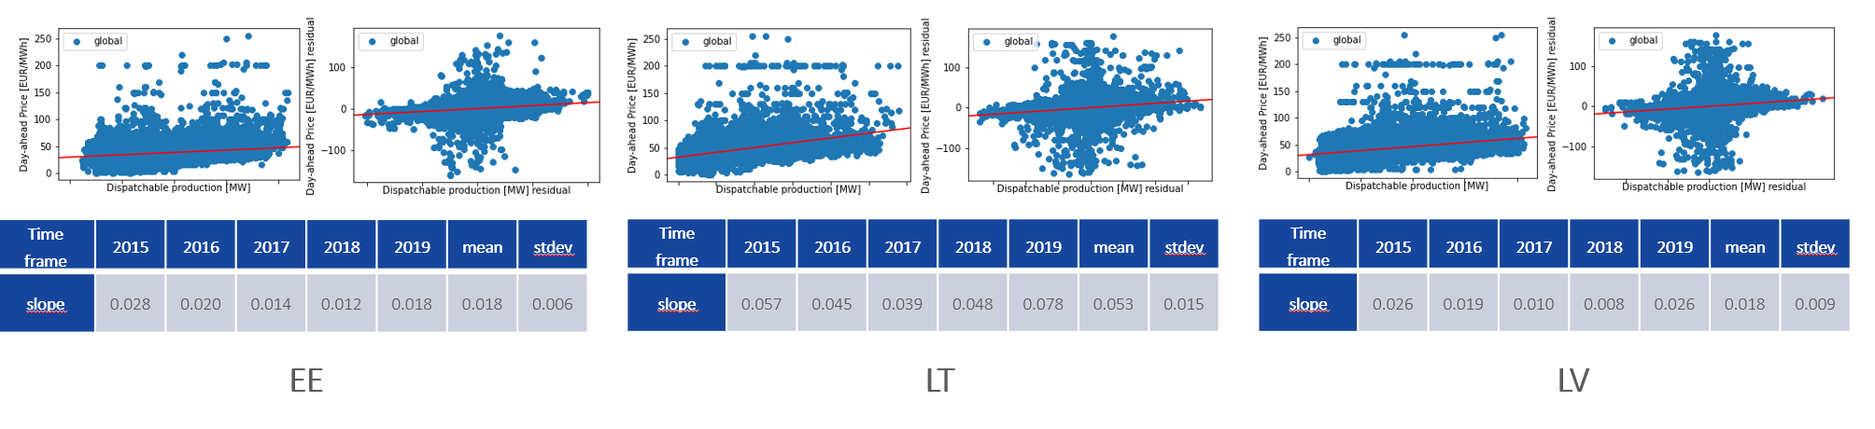

As can be followed in the numerical example brought forward in section 2.1.2, only information regarding the value of the price-volume sensitivity is not enough to approximate the interaction between the bidding zones. More data regarding the status of the bidding zones is needed for the interaction, more precisely:
- The day-ahead market price in each bidding zone and for each MTU;
- The net position of each bidding zone for each MTU.
These parameters needed for input shall be acquired from the selected reference day, i.e the chosen reference day shall determine the initial price levels and net positions of each of the bidding zones. However, as indicated before, these prices and net positions are subject to change, according to the changed NTC values or competition between the DA and the BC markets.
Thus, the market situation is forecasted, but areas are also allowed to increase or decrease their supply/demand as the market situation (CZC limitations or value) changes.
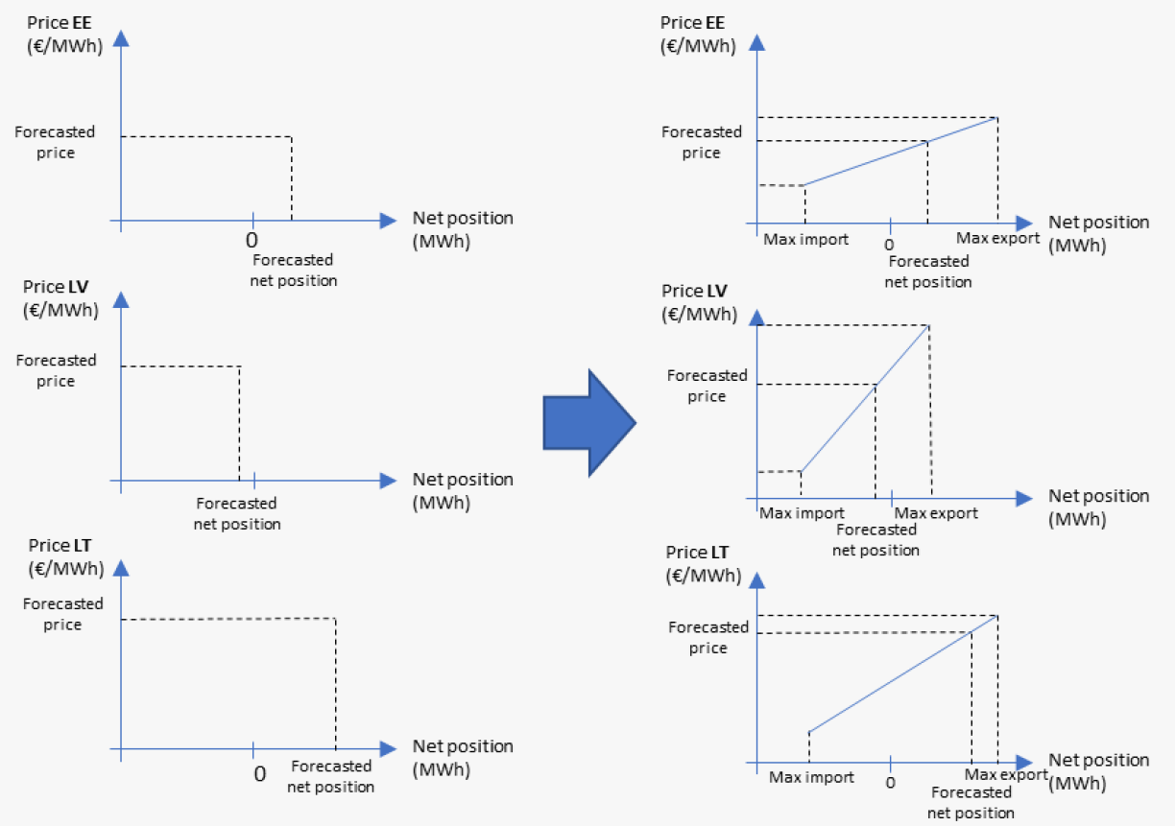

The change in the day-ahead market price of a bidding zone can then be expressed by the forecast market price and the anticipated change in the net position:

$${MCP}_{1,a}^{DAM}={MCP}_{0,a}^{DAM}+α_{a}^{DAM}×V_{a}$$
Where
DAM – Day-ahead market;
a – bidding zone a;
$α_{a}^{DAM}$ – DAM price volume sensitivity of bidding zone a;
${MCP}_{0,a}^{DAM}$ – the forecast DAM price from the reference day methodology in bidding zone a;
${MCP}_{1,a}^{DAM}$ – the anticipated DAM price after the shift in net position in bidding zone a;
$V_{a}$ – change of net position from the forecast value for bidding zone a.

From the formulation, it can be observed that the net position and the forecast DAM price can move in harmony. Therefore, if one areas export flow is restricted, for instance, the DAM market price is anticipated to be lowered as a result.

    - Day-ahead proxy in the procurement optimization algorithm
In the procurement optimisation function, the total welfare for the balancing capacity market and the forecast welfare for the day-ahead market need to be expressed. As there is no price on the TSO demand on the balancing capacity market, the welfare in the balancing capacity market can be expressed through the costs of the market, i.e sum of costs of all accepted balancing capacity bids.

Through the day-ahead forecast proxy, the same approach is used for the forecast day-ahead market welfare. Thus the costs for the day-ahead market are expressed by the volume of accepted bids multiplied by their price:
$$C^{DAM}= \sum_{i}{q_{s,i}×p_{s,i}}$$
However, in the day-ahead forecast proxy, the day-ahead market is not expressed by individual bids, but instead by a continuous supply curve. Instead of individual bids, the sum of total accepted volume shall then be observed. It should be kept in mind that from the reference day the net position for each of the bidding zones is already observed. This means that in the procurement optimization function the welfare change compared to the reference day is observed, not the actual total welfare.

In case the clearing price in a bidding zone changes, the change in welfare in that bidding zone through the price volume sensitivity can be expressed as:
$$∆C^{DAM}={∆V}_{a}\frac{{MCP}_{0,a}^{DAM}+{MCP}_{1,a}^{DAM}}{2}$$
The new clearing price is a function of the change is volume of accepted energy in the bidding zone and thus the following substitution can be made:
$${MCP}_{1,a}^{DAM}=α_{a}^{DAM}×{∆V}_{a}$$
Finally, through the accepted volume of day-ahead energy in each of the bidding zones, the forecast clearing price and the price-volume sensitivity, the welfare change in the day-ahead market shall be expressed as follows:
$$∆C^{DAM}= \frac{{∆V}_{a}×\left({MCP}_{0,a}^{DAM}+α_{a}^{DAM}×{∆V}_{a}\right)}{2}$$

  - The procurement optimization function
As determined above, in the procurement optimization function, the forecasted welfare for the day-ahead market is compared to the actual welfare of the balancing capacity market. As a simplification of the function, only the cost aspects of the welfare are represented. Therefore, the formulation of the procurement optimization function objective function can be expressed as:
$$F_{Obj}= C^{DAM}+C^{BC}$$
The term $C^{DAM}$ represents the forecast welfare aspect of the day ahead market and was elaborated in the previous section. The term $C^{BC}$ represents the welfare term of the balancing capacity market and can be expressed through the socio-economic costs of fulfilling balancing capacity demand:
$$C^{BC}= \sum_{i}{{bidcost}_{i}×{bidvolume}_{i}×{selected}_{i}}$$
Combining the meanings of $C^{DAM}$ and $C^{BC}$ the final form of the objective function can be expressed:
$F_{obj}= \sum_{a}{\left[∆V_{da,a}×\left({MCP}_{0,a}+α_{a}×{∆V}_{da,a}\right)\frac{1}{2}\right]}+\sum_{i}{\left({bidcost}_{i}×{bidvolume}_{i}×{selected}_{i}\right)}$
Where:
${bidcost}_{i}$ - the cost of bid i;
${bidvolume}_{i}$ - the volume of bid i;
${selected}_{i}$ - a boolean determining whether bid i is accepted or not;
${∆V}_{da,a}$ - the deviation of the forecast net position of bidding zone a;
${MCP}_{a}$ - the forecasted day-ahead market price in bidding zone a;
$α_{a}$ - the price/volume sensitivity of day-ahead bidding zone a.

Due to the fact that only the cost aspect of socio-economic welfare is represented in the objective function, the value of $F_{Obj}$ shall be minimized during the optimization process, to find the solution with the highest possible welfare.

- Mathematical formulation of the Baltic balancing capacity optimisation algorithm
As established in the previous section, the objective function of the balancing capacity procurement algorithm consists of the forecasted cost for the day ahead market and the actual cost of the balancing capacity market. The value of the objective function is minimized and the results with the highest possible welfare, given the inputs, is delivered for each day. The algorithm is also subject to a set of mathematical constraints.
  - Allocation of CZC
The forecast algorithm will allocate the CZC for balancing capacity and the exchange of energy in the day-ahead timeframe. The three Baltic bidding zones form an LFC block, within which imbalance setting takes place. As such, up and down regulating bids are never activated simultaneously and CZC need not be allocated for up and down regulating capacity both, but only the largest of the two must be allocated. Thus, for any existing CZC between areas a and b within the Baltic LFC block, for both directions, two equations are defined for the allocation of CZC, as described by equations 5.1 and 5.2, both of which will be active at the same time during the optimisation procedure.
$V_{a→b}^{DAM}+ {CZC}_{a→b}^{aFRR+}+ {CZC}_{a→b}^{mFRR+}≤{NTC}_{a→b}$ (5.1)
$V_{a→b}^{DAM}+ {CZC}_{b→a}^{aFRR-}+ {CZC}_{b→a}^{mFRR-}≤{NTC}_{a→b}$ (5.2)
This aspect of CZC allocation is further elaborated on in section 4.

  - Product balances
Product balances are observed for all balancing capacity products (including up and down separately). Due to the nature of the day-ahead market value forecast methodology implemented, the day-ahead energy balance is also observed in the context of the day-ahead energy market proxy.

    - The day-ahead energy balance
The day-ahead energy balance is established for each of the bidding zones and consists of the forecasted net position of each bidding zone from the reference day. The forecast net position of the bidding zone can be altered during the optimization process, when CZC allocation for the exchange of energy is changed and thus the generation/load levels in bidding zones are also anticipated to be changes. Thus the net positions of bidding zones must change in harmony with the CZC allocation. For each of the bidding zones, the day-ahead energy balance is expressed as shown in equation 5.3
${NP}_{FC,a}+{∆V}_{da,a}+ V_{→a}- V_{a→}=0$ (5.3)
Where:
${NP}_{FC,a}$ – forecasted net position of the bidding zone a, according to the reference day;
$∆V_{da,a}$ – adjustments in the net position of bidding zone a due to changes in day-ahead price (the adjustment can be positive or negative);
$V_{→a}$ - sum of forecasted import energy volumes of bidding zone a;
$V_{a→}$ - sum of forecasted export energy volumes of bidding zone a.

    - The balancing capacity balance
Because the Baltic TSOs implement an extensive balancing capacity sharing arrangement within the Baltic LFC block, the balancing capacity balance equation is not completely analogous to the day-ahead energy balance equation. Namely, in the case of sharing, a bidding zone can have access to the same resource it is dispatching via CZC to other bidding zones. Furthermore, because all the capacity is envisaged to be shared, there is no export of balancing capacity aspect in the balancing capacity balance equation. In conclusion, the balancing capacity balance equation is described by equation 5.4.
$\sum_{i}{\left({bidvolume}_{i}×{selected}_{i}\right)}+ V_{→a}^{BC}≥D_{a}^{BC}$ (5.4)
Where
${bidvolume}_{i}$ – is the volume of bid i which is located in bidding zone a;
${selected}_{i}$ – Boolean variable that determines whether bid i in bidding zone a is accepted;
$V_{→a}^{BC}$- total volume of imported balancing capacity from other bidding zones;
$D_{a}^{BC}$ – balancing capacity demand for a product in bidding zone a.

    - The balancing capacity export restriction
Due to the nature of sharing of reserves and the special equation for the balance of balancing capacity equation, a special constraint needs to be set in place which modifies the amount of balancing capacity which can be shared between bidding zones a and b. In essence, balancing capacity which has been imported from bidding zone b to bidding zone a, cannot be shared back from bidding zone a to bidding zone b. The mathematical formulation is defined by equation
$V_{a→b}^{BC}≤ \sum_{i}{\left({bidvolume}_{i}×{selected}_{i}\right)}+V_{→a}^{BC}- V_{b→a}^{BC}$ (5.5)

- CZC allocation determination
Netting of CZC allocated to the exchange of balancing capacity or sharing of reserves is not possible between standard upward and downward balancing capacity bids and standard balancing capacity bids from different standard balancing capacity products.
However, for standard balancing capacity products of opposite directions, the same CZC can be used. For example, if CZC is allocated to exchange or share mFRR up from BZ A to BZ B, and also CZC is allocated to exchange or share mFRR down from BZ B to BZ A, then the resulting CZC allocation on the border of BZ A and B would be of the same direction. Because the Baltic LFC block shall engage in common imbalance management, there will be no simultaneous activation of up and down balancing products, it is not necessary to allocate enough CZC to accommodate the balancing energy flows of both products. Therefore, within the Baltic LFC block when standard balancing capacity products of up and down direction are to be allocated such that the CZC allocation would be cumulative, instead the highest of the two is allocated. This is in line with the envisaged imbalance management of the Baltic LFC block as well as maximizes the usage of existing CZC assets. The comparison between netting and the double usage of CZC is illustrated in the image below. On the image, netting is illustrated on the left (not possible); overlapping usage of CZC is illustrated on the right (possible).
CZC allocation = max(60;40) = 60 MW
mFRR down exchange from A to B = 40 MW

CZC allocation
mFRR up exchange from A to B = 60 MW
CZC allocation

mFRR up exchange from A to B = 60 MW
mFRR up exchange from B to A = 40 MW

CZC allocation = 60 – 40 = 20 MW

- The maximum and optimal volume of allocated CZC for the exchange of balancing capacity or sharing of reserves
In the CZC Study 1 serious limitations have been identified with the maximum allocation level on the exchange of balancing capacity established by ACER decision 10/2021 (20% in normal situations, 50% in case of scarcity). In particular, it was found that the normal situation maximum allocation level prevented the procurement of the necessary reserve and led to frequent balancing capacity scarcity situations.
The Baltic TSOs see that (i) a certain level of CZC allocation is necessary to avoid balancing capacity scarcity and (ii) a possibly higher level of CZC is necessary to reach the optimal allocation between balancing capacity and energy markets.
In order to assess the impacts of CZC allocation on balancing capacity procurement and reserve sharing, a sensitivity study has been designed in CZC Study 2. The impact of the maximum allocation limit is studied on the four reference weeks identified with four key performance indicators:
- Balancing capacity procurement where the ability to procure the necessary balancing capacity is analyzed depending on the maximum allocation limit;
- System costs where the system costs for the day-ahead energy and balancing capacity markets are assessed for the Baltic countries and their neighbors;
- Cross-zonal capacity usage where the usage of interconnectors within the Baltics and with neighboring countries is analyzed;
- Day-ahead energy market prices where the prices for energy within the Baltics and with neighboring countries are analyzed.

Simulations were performed with a maximum allocation limit for the exchange of balancing capacity ranging from 100% to 0% with 5% steps (21 simulations).
With a 100% limit, the co-optimization is able to allocate the CZC between the energy and balancing capacity markets freely, effectively finding the optimal solution (least overall cost). When reducing the maximum allocation limit on the exchange of balancing capacity, the system is more constrained and the total cost increases.

In the Baltic CCR, the dimensioning of FRR is directly linked to the NTC with neighboring countries. Upward FRR must cover the loss of an interconnector when importing energy and downward FRR must cover the loss of an interconnector when exporting energy.
In case of balancing capacity scarcity, it might be necessary to reduce the NTC with neighboring countries so as to avoid the exposure to an imbalance that could not be mitigated.
To model the NTC reduction in the case of balancing capacity scarcity, two iterations of the simulation were performed. In the first simulation, NTCs with neighboring countries are not limited and balancing capacity scarcity situations can be observed. In the second simulation, the NTC with neighboring countries (Estonia-Finland and Lithuania-Sweden) are reduced as a result of the balancing capacity scarcity. NTC reductions are applied as follows:
- The available capacity for imports to Estonia from Finland (resp. exports from Estonia to Finland) is reduced by the amount of upward (resp. downward) reserve scarcity observed in Estonia.
- The available capacity for imports to Lithuania from Sweden (resp. exports from Lithuania to Sweden) is reduced by the amount of upward (resp. downward) reserve scarcity observed in Lithuania.

  - Balancing capacity procurement

In CZC Study 2 following observations has been made:
- When sufficient CZC is allocated to the exchange of balancing capacity, reserve is procured where it is cost-efficient. The reserve sharing target is met and the Baltic countries share a total of 710 MW of FRR procured in both directions.
- With lower levels of CZC allocated to the exchange of balancing capacity, reserve is procured where it is available and exchanged within the set limits. The reserve sharing target cannot be met and the Baltic countries procure larger amount of FRR overall (up to 1800 MW in the least favorable cases).
- With insufficient levels of CZC allocated to the exchange of balancing capacity, sufficient reserve cannot be procured, creating scarcity situations. The scarcity situations increase as the maximum allocation limit decreases.

  - System costs

Comparing system costs allows to assess the economic efficiency for both the day-ahead energy and the balancing capacity markets as a function of the maximum allocation limit.
Figure X shows the total system costs for the Baltic countries (day-ahead energy and balancing capacity markets combined) and for the neighboring countries (day-ahead energy market only) as a function of the allocation limit on the exchange of balancing capacity.
Two main observations can be made:
- For the neighboring countries, total system costs are stable and tend not to be affected by the limit on the exchange of balancing capacity within the Baltic countries (high allocation limit restricting the exchange of energy within the Baltic countries or low allocation limit with scarcity resulting in NTC reductions with the neighboring countries).
- For the Baltic countries, total system costs are relatively stable until scarcity appears for maximum allocation levels below 50%. In the Winter week, the generation dispatch is very constrained regardless of the maximum allocation limit, leading to stable total system costs.

Figure X. Total system costs

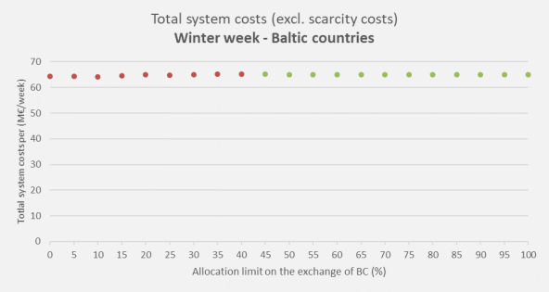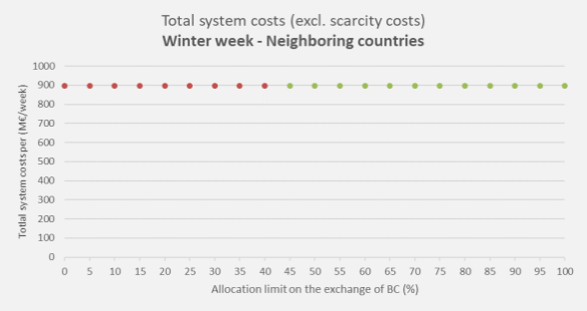
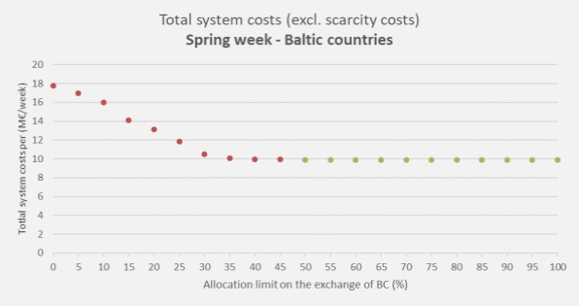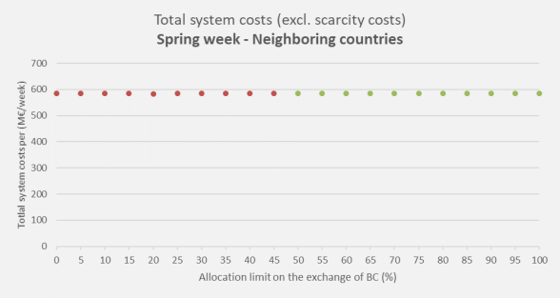
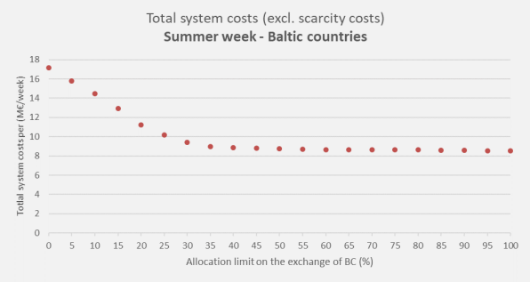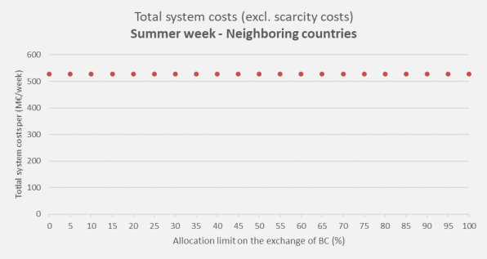
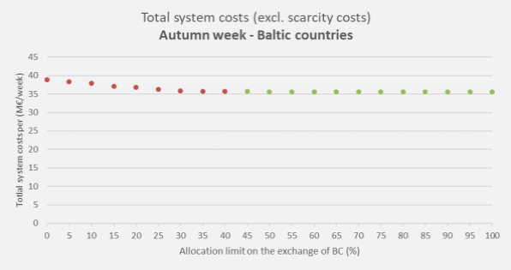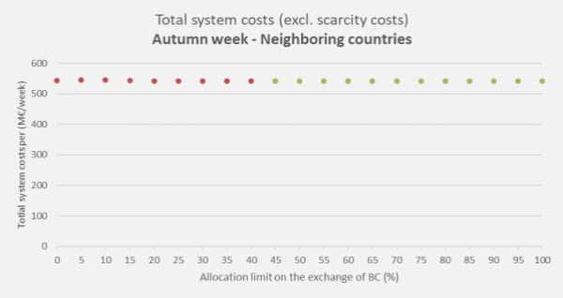

  - Cross-zonal capacity usage
It has been observed that within the Baltics, the CZC usage increases as the allocation limit increases. Restricting the CZC usage for the exchange of balancing capacity does not necessarily result in greater energy exchange as more generation capacity is dedicated to local balancing capacity procurement. With neighboring countries, the CZC usage generally decreases as the CZC allocation limit increases. Similarly, when the CZC allocation limit is low, the level of energy import in the Baltics is higher as more capacity is dedicated to local balancing capacity procurement.

  - Day-ahead energy market prices
For allocation limit levels between 0% and 50%, day-ahead energy market prices tend to be slightly higher as the balancing capacity scarcity situation in the Baltics impose a reduction of NTCs with neighboring countries. Under normal conditions, DAM prices are up to 45% higher in the Baltics and up to 7% higher in Finland and Sweden than in the optimal case (100% allocation limit). Day-ahead energy market average prices in the area are the lowest when the allocation limit for the exchange of balancing capacity is set to 35% and above.
- For allocation limit levels above 50%, day-ahead energy market prices are stable. The reduction of CZC allocated to the exchange of energy does not impact the market prices.

  - Outcomes

The Baltic CCR TSOs have established that a high CZC allocation is imperative to the functioning of the Baltic power system. It has been determined in CZC Study 2 that operating below 50% allocation limit is not possible without frequent balancing capacity scarcity in the Baltic countries. Balancing capacity scarcity shall lead to significant negative consequences, such as:
- The Baltic countries’ inability to fulfil their balancing obligations to the CESA power system
- If insufficient FRR capacity is available to either Estonia or Lithuania, the NTC values of HVDC links in the day-ahead market between Estonia and Finland or Lithuania and Sweden/Poland must be restricted, respectively.
Under CZC Study 2 it was found that:

- Below 50%, an infeasible regime is found as consistent balancing capacity scarcity situations are observed. It is not possible to procure the necessary balancing capacity, NTCs with neighboring countries have to be de-rated.
- Between 50% and 65%, a sub-optimal regime is found. For normal situations, it is possible to procure the necessary balancing capacity. For degraded situations, it is not possible to procure the necessary balancing capacity but the magnitude and the overall system cost decrease.
- Above 65%, the optimal regime is found. The overall system costs are minimum (or close to minimum) for both normal and degraded situations.

Additionally to the CZC Study 2 results, TSOs evaluated overal situation in Baltic balancing market, ACER decision 10/2021, legal framework under Electricity Balancing guidelines, Electricity Regulation and concluded that:

- As was stated in CZC Study 2 the range for optimal regime is between 50 and 65 % without any major difference for balancing market, in order to allocated the greater part for the day-ahead market, TSOs came t conlusion that the optimal allocation equals 50% under normal situations.
In the context of FRR scarcity in the algorithm, the Baltic TSOs foresee a higher CZC limit. However, due to the fact the day-ahead market situation is formulated as a forecast which may contain inconsistencies regarding the availability of generated energy in each bidding zone, it is possible that the balancing capacity procurement algorithm does not detect day-ahead scarcity similarly accurately as the balancing capacity scarcity. Thus it is foreseen that in case of scarcity, not all CZC could be allocated for balancing, in order to not cause curtailment in the day-ahead market due to insufficient CZC available for the exchange of energy.
- Accordingly, TSOs deem it necessary to allocate the part of CZC in case of degraded situation up to 70 % instead of 100 %, in this case again allowing for the day-ahead market to function.

Key findings:

- The generation capacity is scarce and under generation or transmission capacity maintenance/outage, procuring the necessary balancing capacity is not guaranteed and leads to frequent scarcity situations regardless on the limit on the exchange of balancing capacity.
- When scarcity situations are expected, higher maximum allocation levels are necessary to mitigate entirely or partially the scarcity.
- No negative impacts are observed on the neighboring countries (Sweden, Finland and Poland) when allocating large shares of CZC for balancing capacity on the Estonian-Latvian and Latvian-Lithuanian border, total system costs and day-ahead energy prices remain stable.
- Large impacts are observed for the Baltic countries when allocating low shares of CZC for balancing capacity on the Estonian-Latvian and Latvian-Lithuanian border as both the balancing capacity and day-ahead energy market costs increase.
- according to above-mentioned reasons, the CZC allocation limitations for balancing capacity have been determined to be 50% of CZC calculated for the day-ahead timeframe, and in the case of balancing capacity scarcity this number can be extended to 70%.

- Impact of allocating large shares of CZC for balancing capacity to neighbouring countries
According to the study results, Day Ahead Market prices show overall good convergence in the region except with PL whose price is mostly dictated by its own generation mix.
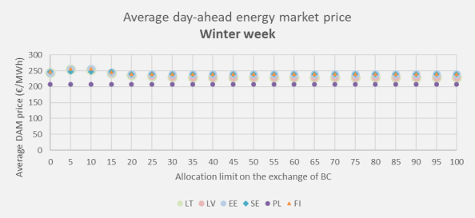

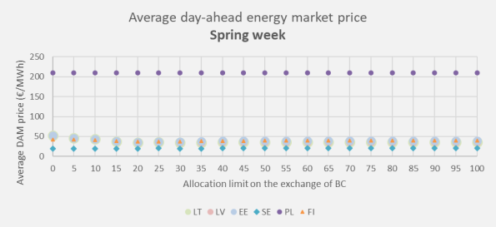

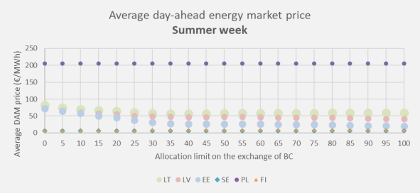

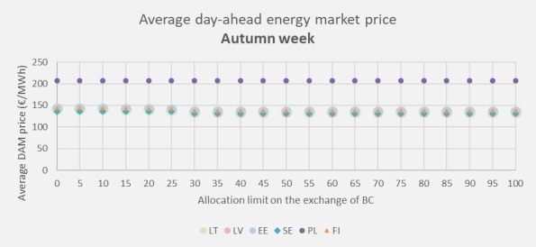

Allocating large shares of CZC for the exchange of balancing capacity implies that the CZC allocated to the day-ahead energy market could be reduced within the Baltics and could by extension restrict the commercial capacities in the region. However, the allocation of large shares of CZC for balancing capacity in Baltic countries have a very limited impact to the Polish, Finnish and Swedish day-ahead market prices.

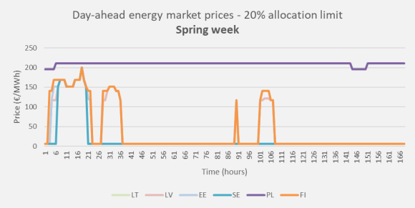

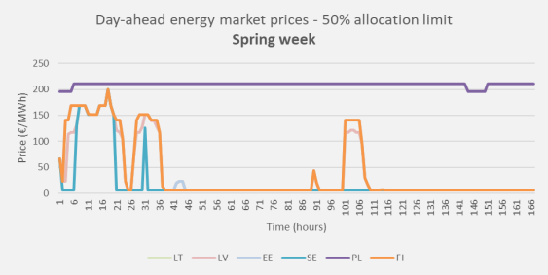

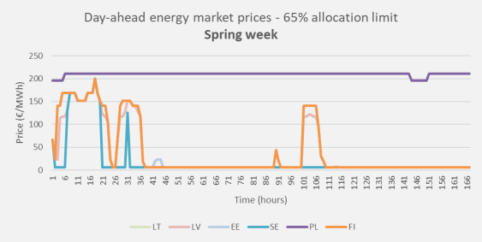

For the neighboring countries total system costs are stable and do not seem to be affected by the balancing capacity procurement situation within the Baltics.
No negative impact is observed on the neighboring countries when allocating large shares of CZC for the exchange balancing capacity.
- Further considerations on CZC limits
The Baltic CCR acknowledge the problems which may arise when comparing the forecast market value of CZC for the exchange of energy with the actual market value of CZC for balancing capacity. However, due to the tight and illiquid situation in the Baltic balancing capacity market, a significant share of CZC is necessary to be allocated for balancing, as highlighted above in several instances. However, there is a special situation where balancing capacity is not in direct competition with the day-ahead market, and that is when balancing capacity products would be allocated on CZC in the opposite direction of the forecast flow of energy in the day-ahead market.
Therefore, the Baltic CCR TSOs are considering a further future amendment of the methodology where the direction of forecast day-ahead flows are taken into account when determining the CZC allocation limits. The proposal would include forecasting the day-ahead flows as the first step, then applying different CZC allocation limits for BC for different directions:

- The standard 50%/70% CZC allocation limit for BC shall be applied to all borders
- The limit is increased (for example, to 80% or 90%) on the CZC with a specific direction where the flow forecast indicates a flow in the opposite direction.
It is clear the forecast of flows in the day-ahead market shall contain errors. Thus it is foreseen that the forecast day-ahead flow which triggers a higher limit of CZC allocation for balancing must contain within itself some kind of margin of error, such as a flow of at least 300 MW, interconnector usage above a certain threshold or similar. The concrete trigger has not yet been decided and would depend on the specific forecast methodology used and its accuracy, therefore further investigation is required before a detailed proposal can be added to the Baltic CCR methodology of market-based allocation CZC allocation process for balancing capacity.

