The Electricity Market’s Supplier Change Process from 01.01.2023
Estfeed Business Guide

Version 1.0 (agreed to be implemented from 01.01.2023)
11.2021

Table of Contents
1. Definitions 2
2. Open supplier change process 3
2.1. General principles 3
2.2. Supplier change process until 31.12.2022 4
2.3. Supplier change process from 01.01.2023 5

Definitions
The definitions used in this business guide are used in the same meaning as in the Electricity Market Act and legislation established based on the act and are specified below:
  - Estfeed is the name of a data exchange platform (hereinafter referred to as AVP);
  - Open supplier (OS) is a market party that supplies its customers with all the energy (electricity or gas) they need or balances the customer’s production and acquisition of energy and the difference between its use and supply, by supplying the amount of energy that is lacking or by receiving the surplus during each hour;
  - Named supplier provides universal service and operates as an open supplier in the network operator’s entire service area based on §76 of the Electricity Market Act;
  - Balance Provider (BRP) is an open supplier who has entered into a balance agreement with the System Operator and who is responsible for balance planning and imbalance settlements in its entire network area;
  - Network operator or grid operator (GO) is a regulated entity that provides a network service through the network and is responsible for collecting and submitting metering point technical data and measurement data related to metering points in its network area. The network operator itself is a customer in terms of network losses.
  - Open supply agreement is an electricity purchase-sale agreement in which the calculation of supply is based on the quantity of metering data at the metering point;
  - Open supply portfolio agreement is an electricity purchase-sale agreement for a network operator in which the calculation of supply is based on the quantity of metering data at all the metering points in the network operator’s entire area of operation;
  - Balance agreement is an open supply agreement between the System Operator (Elering) and balance provider;
  - Named supplier agreement is an agreement between a network operator and an open supplier that names the open supplier as the provider of universal service instead of the network operator for clients without an open supply agreement in its entire area of operation. Agreement information is sent to Datahub by the network operator;
  - Network agreement is an agreement between the network operator and customer regarding the usage of grid and transmission of electricity in the connection point. It also ensures that the transmitted electricity is metered and/or determined. Agreement information is sent to Datahub by the network operator;
  - The agreement period is one calendar day starting at 00.00. This means that an open supply or a grid agreement can begin and/or end with the accuracy of one day (24h);
  - Market participant is a client, who buys or sells electricity under a grid agreement (consumer or producer) or on a portfolio basis (open supplier and network operator).

Open supplier change process

General principles
The rules of open supply and changing the open supplier are set out in the requirements of the Electricity Market Act and the Network Code on the Operation of the Electricity Market.
The general principles for changing the open supplier are as follows:
      - Client with a network agreement, who is either a consumer or producer, takes part in the open supply process separately with every metering point owned. If the client with a network agreement is another network operator or an open supplier (electricity undertakings), then the network agreement is signed for every metering point in its operating area.
      - A network agreement is signed with the connection point network operator, who sends the info to Datahub. Open supply agreement can be signed by the owner of the network agreement in the same metering point, therefore a valid network agreement is the basis for signing an open supply agreement.
      - If the network agreement ends, then so does the open supply agreement.
      - If a market participant owns a valid network agreement, but does not own an open supply agreement, then according to the Electricity Market Act the open supplier for that market participant is the network operator of the market participant’s metering point. The network operator may delegate the provision of the open supply service to another open supplier, in which case the network operator must enter the details of its named supplier into the Datahub. A service with no open supply agreement is divided into three categories:
        - A small consumer in a connection point up to 63A is a universal service client. The price of universal service is regulated by the Electricity Market Act (is based on the market price, to which the network operator adds its cost margin). The network operator shall publish the terms and conditions of the universal service on its own (or its open supplier’s) website;
        - Consumers in a connection point of more than 63A purchase the open supply service at the price of balancing electricity;
        - In the absence of an open supply contract, the producers shall transmit electricity to the network free of charge.
      - An uninterrupted open supply chain for the whole system is guaranteed through the Datahub, which means that each market participant’s metering point belongs to one open supplier’s and its balance provider’s operating area at any given time.

Supplier change process until 31.12.2022
The change of open supplier takes place at the change of calendar month following the process below:
- The new open supplier can send the information of a new open supply agreement to Datahub at least 7 days before it is concluded provided that the existing agreement has been terminated by the previous open supplier. The new open supply agreement can be concluded at the change of calendar month;
- The existing open supplier can send the agreement termination date to Datahub at least 7 days in advance (can be terminated any day, but given that a new agreement can be signed only at the change of calendar month, the client will have to stay on universal service till new agreement is concluded);
- Agreements shall be concluded and terminated with an accuracy of one calendar day, starting at 00.00 and ending at 24.00;
- If the client has authorized the new open supplier to terminate its existing agreement for the purpose of signing a new agreement, then the data exchange between the parties will take place outside of Datahub;
- If the market participant has not signed a new open supply agreement at least 7 days before the change of calendar month, then the market participant will remain in the network operator’s open supply portfolio (so-called universal service) with the chance to make a supplier change the next calendar month;
- If a market participant has a new network agreement (e.g., real estate transactions) that is concluded on any day of the calendar month, then the new open supply agreement must also start on the same date as the start date of the network agreement or later with the change of calendar month. The new open supplier has the option to enter an open supply agreement with a new network agreement customer within two days of the start of the agreement (this is because new network agreements are often entered one day in advance);
- Open supply portfolio agreement change from one electricity undertaking to another (open supplier and network operator) shall also take place at the change of the calendar month and the agreement information shall also be sent to Datahub at least 7 days in advance;
- The open supply agreement is entered as fixed-term or indefinite, but the Datahub has no information on whether the termination of a fixed-term agreement will bring the market participant penalties or not;
- Open suppliers have an option to retroactively resend fixes in agreement information to Datahub, if the changes have been approved by the metering point network operator, the related open supplier, and the balance provider.

Supplier change process from 01.01.2023

Fixed-term and indefinite open supply agreements
An open supply contract may be signed for each market participant either for an indefinite period or for a fixed term, depending on the terms of the agreement set between the open supplier and the market participant. The open supplier must provide the agreement information to Datahub as follows:
- The open supplier enters agreement information to Datahub as indefinite, if the agreement signed with the market participant does not have a fixed end date and the termination of the agreement shall not give the open supplier the right to demand any penalties from the market participant.
- The open supplier enters agreement information to Datahub as fixed term, if the agreement signed with the market participant has a fixed end date and the termination of the agreement may give the open supplier the right to demand penalties from the market participant. Therefore, in the case of a fixed-term agreement, the open supplier is obliged to enter information into the Datahub about the end date of the open supply agreement and whether the open supplier has the right to demand penalties from the market participant for early termination of the agreement (yes/no). The Competition Authority supervises the proportionality of penalties for early agreement termination (fee information has not been forwarded to Datahub).

Open supplier change process
The change of open supplier takes place on any calendar day by following the process below:
- The supplier change process in Datahub starts with the new open supplier sending the new agreement information about the market participant into Datahub at least 14 days in advance. The open supplier sends the following information to Datahub: market participants ID, metering point EIC code, open supply agreement start and end date, early termination penalty information (yes/no). Upon receiving new agreement information about the market participant, the Datahub immediately terminates the existing open supply agreement and sends the agreement amendment information to the related open suppliers and the network operator;
- An open supply agreement can be concluded with an accuracy of one calendar day, starting at 00.00 and ending at 24.00;
- Before concluding an open supply agreement through Datahub, the new open supplier must check whether the market participant has a metering point with a valid network agreement for which the person wishes to enter into an open supply agreement and whether the market participant's valid open supply agreement includes a penalty for early termination. In the latter case, the open supplier has an obligation to inform the market participant of the agreement’s requirement to ensure that the market participant is aware of the potential costs of changing suppliers;
- If a market participant has a new network agreement (e.g., real estate transactions) that Is concluded on any day of the calendar month, then the new open supply agreement can start on the same date as the start date of the network agreement, or a later date entered by the open supplier at least one day in advance. For a period, different from the start of the network agreement and the effective date of the new open supply agreement, the open supplier of a market participant shall be its network operator or the named supplier of the network operator;
- If a market participant has not entered into a new open supply agreement at least 1 day in advance, the market participant shall remain in the open supply portfolio of the network operator with the possibility to enter into a new open supply agreement at least 1 day in advance. This situation may occur if the open supplier has entered an end date for the agreement in the Datahub, but the market participant has not entered into a new open supply agreement or if it is a new network agreement for which the market participant has not concluded an open supply agreement;
- If the market participant's network agreement ends, then the Datahub will also terminate the market participant's open supply agreement with the same date;
- The consumer can withdraw from an open supply agreement within 14 days of concluding it. In this case, the open supplier will cancel the agreement in Datahub before the agreement is concluded (no later than 1 day in advance). The open supplier can also send the termination of agreement with the market participant to Datahub for other reasons at least 1 day in advance;
- Electricity undertakings have an obligation to have an open supply agreement. The change of open supply portfolio agreement from one electricity undertaking to another (open supplier and network operator) is done at least 7 days in advance. If the open supplier does not have an open supply portfolio agreement, it shall not be able to act as an open supplier and the system operator shall terminate its operations and open supply agreements. If the network operator does not have an open supply portfolio agreement, then its so-called parent network operator shall be named as its open supplier and the system operator shall forward the relevant information to the Competition Authority;
- Open suppliers have an option to retroactively resend fixes in agreement information to Datahub, if the changes have been approved by the metering point network operator, the related open supplier, and the balance provider.

Models for open supplier change process

Process of open supplier change for market participant with an existing open supply agreement
For changing its open supplier, the market participant can terminate an existing open supply agreement through the new open supplier change process, based on which the new open supplier is authorized to terminate the market participant’s existing open supply agreement through Datahub data exchange. The supplier change schedule is determined by the Network Code on the Operation of the Electricity Market (from 01.01.2023 the change period is at least 14 days in advance).
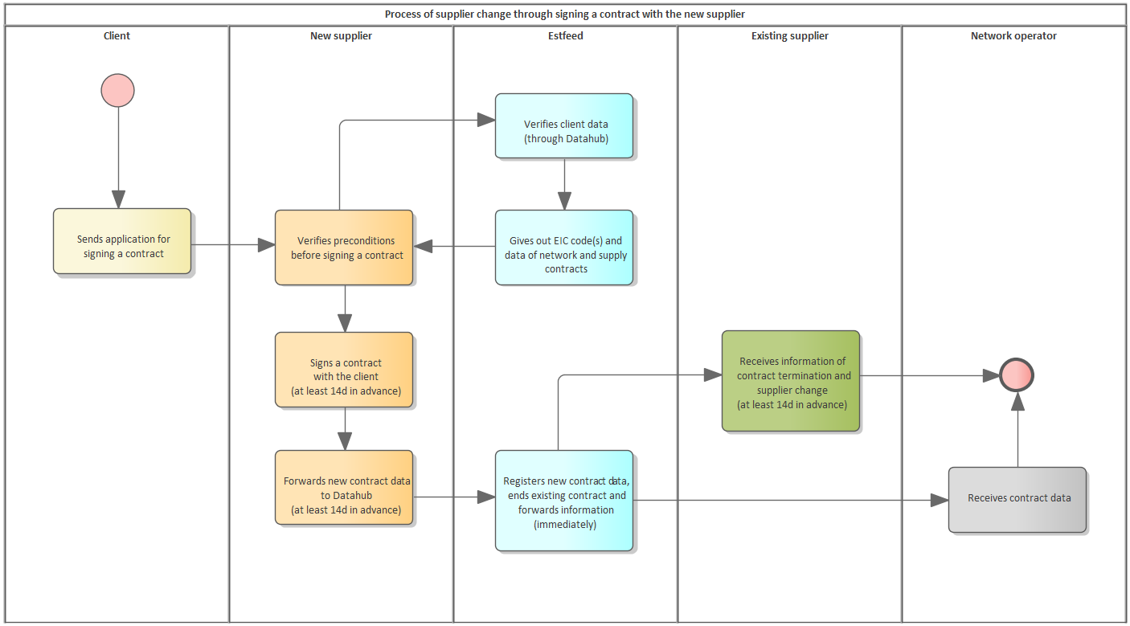
Figure 1. Process of supplier change through signing a contract with the new supplier
If the open supplier sends the new agreement information to Datahub, then the Datahub shall immediately check the correctness of the transmission of the agreement information and forward the agreement termination message to the existing open supplier and the agreement registration message to the new open supplier. The Datahub ensures that technically the supplier change has been completed and the information has been forwarded to the parties in less than 24 hours.
Process of supplier change through signing a contract with the new supplier ensures that the client is not left on universal service.

Process of open supplier change for market participant without an existing open supply agreement (so-called universal service client)
If a market participant does not have an open supply agreement for a metering point, then its open supplier shall be the metering point network operator or the named seller of the network operator. In this case, the client can enter into a new open supply agreement if the new open supplier has provided the contract information at least 1 day in advance.
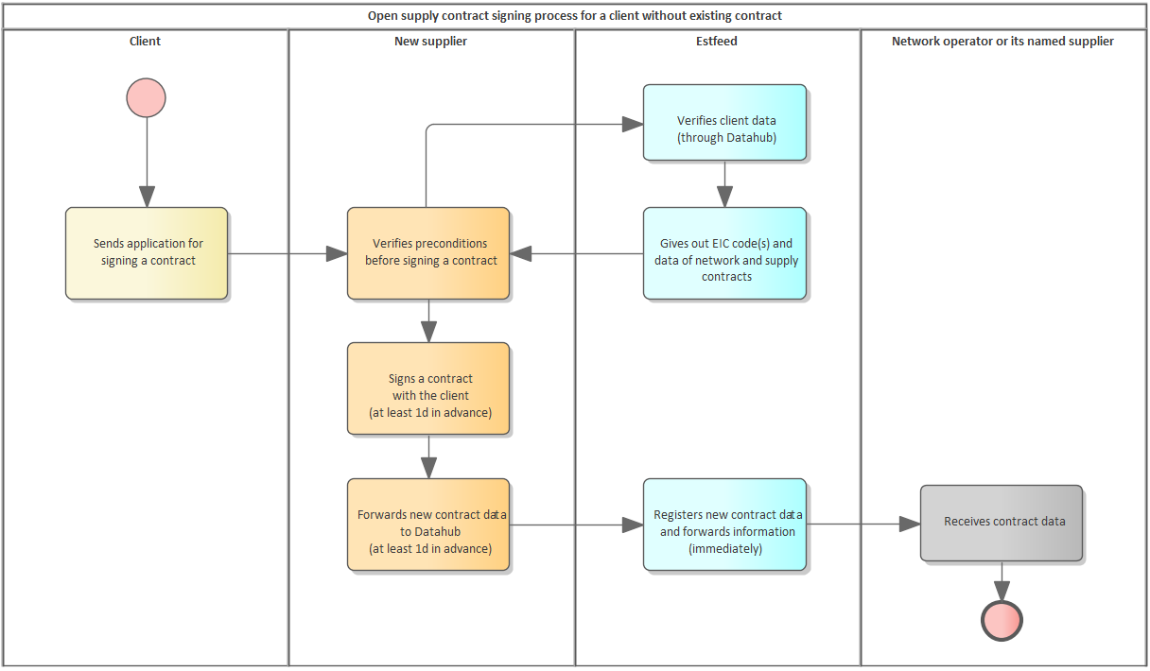
Figure 2. Open supply contract signing process for a client without an existing contract

