Users, functionality and access rights of Datahub
Business guide for Estfeed electricity market information exchange

1.0
03.2022

Table of contents
1. Introduction 3
2. Role-based access rights 4
3. Main functionalities of Datahub 7
4. Access rights to information exchange 8
4.1. Information exchange and access of network operators (including line possessors and charging points) 8
4.2. Access to information for open suppliers 11
4.3. Access to information for balance providers 14
4.4. Access to information for designated sellers 16
4.5. Access to information for aggregators 17
4.6. Access to information for energy services 19
4.7. Access to information for system operator (balance management and renewable energy business process) 19
5. Notification system 20

Introduction
On the basis of § 42 of the Electricity Market Act, Elering shall create an information exchange platform (hereinafter the Datahub) in order for the electricity market to function efficiently and to facilitate competition and administer it so that market participants who are subject to a legal obligation and at the same time have a legal right to submit data have the opportunity to do so in a timely manner, as well as the opportunity to obtain data in a timely manner and on equal terms.
- The rules for submitting data are established in the network code on the functioning of the electricity market.
- Transmission of personalised data via the Datahub to a supplier, aggregator or other energy service, who has no contract with the individual consumer concerned, requires the consent of that consumer. This consent must meet the conditions provided in Regulation (EU) 2016/679 of the European Parliament and of the Council on the protection of natural persons with regard to the processing of personal data and on the free movement of such data, and repealing Directive 95/46/EC (OJ L 119, 04.05.2016, pp. 1−88).
- The data submitted to the Datahub shall be preserved for twelve years and then deleted.

Information exchange shall be ensured to the following electricity undertakings via the Datahub:
- network operator – transmission of metering point(s), information on contracts and metering data; receipt of open supply contracts and information on aggregation contracts;
- line operator and producer – transmission of metering point(s) and metering data;
- closed distribution network – transmission of metering point(s), information on contracts and metering data;
- charging point operator – transmission of metering point(s) and metering data;
- open supplier – transmission of open supply contracts and portfolio contracts and receipt of information on metering points and metering data;
- aggregator – transmission of aggregation contracts and metering data on management of consumption and receipt of information on metering points and metering data;
- balance provider – transmission of information on open supply contracts and portfolio contracts;
- system operator – transmission of information on balance responsibility portfolio contracts and administration of the uninterrupted chain of open supplies.

Provider of energy service shall have access to data only based on the access rights given by a market participant.

Exchange of information with other information systems shall take place based on the rights provided in legislation (e.g. renewable energy information system).

The following main functionalities have been created in the Datahub in order to change open suppliers, administer aggregator contracts, transmit metering data and ensure balance responsibility:
- registration process;
- process for transmitting metering point technical data and metering data;
- process for change of supplier and the messages describing it;
- process for network operators to transmit network invoices;
- channel for exchange of information between open suppliers and network operators;
- administration of uninterrupted chain of open supplies and balance portfolios (balance regions);
- 15-minute balance period information exchange;
- calculation and transmission of aggregated summary reports on balance clarifications;
- transmission of aggregate contracts and metering data of demand side response (DSR).

Exchange of information shall be ensured for electricity undertakings both via machine interfacing (API) and an additional online application for the purpose of transmitting and receiving information. Exchange of information shall be ensured for other energy services via machine interfacing (API). A customer portal has been created where end-users are able to access their data, administer their rights of representation, grant rights to other persons to access the data and view the logs related to queries for information related to their metering points.

Role-based access rights
Elering shall ensure that only parties with the respective right arising from legislation or to whom the market participant has granted the respective right are able to access the information of a market participant.
The general principles of access rights are as follows:
- Electricity undertakings must enter into an agreement with Elering in order to access the information in the Datahub (legal basis), as well as all energy services applying for access to the information of a market participant on the basis of the access rights granted by the latter (authorisation).
- The client of a network contract shall be granted access to the information transmitted via the customer portal. The customer has the right to transmit data on their metering point and metering data to other persons and systems by means of granting authorisation.
Registration and access rights of electricity undertaking and energy services
Once an electricity undertaking or a provider of energy services has entered into an agreement for accessing information with Elering, the latter shall register the company and determine the access rights. Each type of electricity undertaking is differentiated with its own role abbreviation and has access rights based on their role arising from legislation. NB! Open suppliers do not have the default rights created for network operators and network operators do not have the rights of open suppliers, which means that the role of every electricity undertaking shall be separately determined (whereas an electricity undertaking can have several roles).

Type of Datahub user | Abbreviation | Explanation | Open supply portfolio contract obligation
Network operator | GO | Has its own code range.  Responsible for transmitting the technical data, information on network contracts and metering data in its network area. | Yes  Upon the absence of a contract, Elering shall enter it in the open supplier portfolio of the superior network operator.
Line possessor | LO | Has its own code range.  Responsible for collection and transmission of information related to its metering points and metering data. | No  Line possessors are not included in balance – open supply contracts are not added to their metering points (no network contracts are entered into).
Closed distribution network | ISO | Has its own code range.  Responsible for transmitting the technical data, information on network contracts and metering data in its network area. | Yes
Producer operator | PO | Has its own code range.  Responsible for collection and transmission of information related to its metering points and metering data. | No, not included in balance – open supply contracts are not added to their metering points (no network contracts are entered into).
Charging point operator | CO | Has its own code range.  Responsible for collection and transmission of information related to its metering points and metering data. | No, not included in balance – open supply contracts are not added to their metering points (no network contracts are entered into).
Open supplier | OS | An open supplier shall enter the information on the open supply contract entered into with a market participant and also enter the portfolio contract if it provides open supply services to another open electricity undertaking. | Yes
 |  |  | In the absence of an open supply contract, the contracts entered into by an open supplier with a market participant shall be rendered null and void.
Aggregator | AGR | Has its own code range.  An aggregator shall enter the information on the aggregator contract entered into with a market participant and transmit the data on the management of consumption. | Yes
 |  |  | In the absence of an open supply contract, the contracts entered into by an aggregator with a market participant shall be rendered null and void.
Provider of energy services | ES | A provider of energy services shall receive access to information only on the basis of the access rights granted by end-users and does not transmit its own information. | No  The role only constitutes access to information on the basis of authorisation.

Additional roles of open supply

The following additional roles are created arising from contracts in relation to the service of open supply:
Additional role of open supplier | Abbreviation | Explanation | Open supply portfolio contract obligation
Designated (named) supplier | Named | If the network operator does not provide open supply services to the customers of its own network area by itself (if the client does not have an open supply contract), it shall designate one open supplier for its entire area of activity. The network operator shall enter the information on the contract entered into with the designated supplier in the Datahub.  Named supplier shall have the same rights regarding the metering point data and metering data as the open supplier with an open supply agreement. | Yes, open supplier rules
Balance provider | BRP | A balance provider is an open supplier that has entered into a balance agreement with Elering. | Yes. Elering shall enter the information on the balance agreement in the Datahub.
System operator | TSO | Elering serves as the open supplier for balance providers. | Outside the Datahub.

Upon the registration of a company as a user in the Datahub, Elering shall enter the person provided in the contract (with the role name Administrator) as the person mainly chiefly responsible for the information of the company. The Administrator of every company is obligated to input the machine interface configuration and input/administer other users of their company and their rights of representation. The Administrator shall create user accounts for the authorised workers in their company and assume responsibility for administering the access composition of the authorised workers in their company.
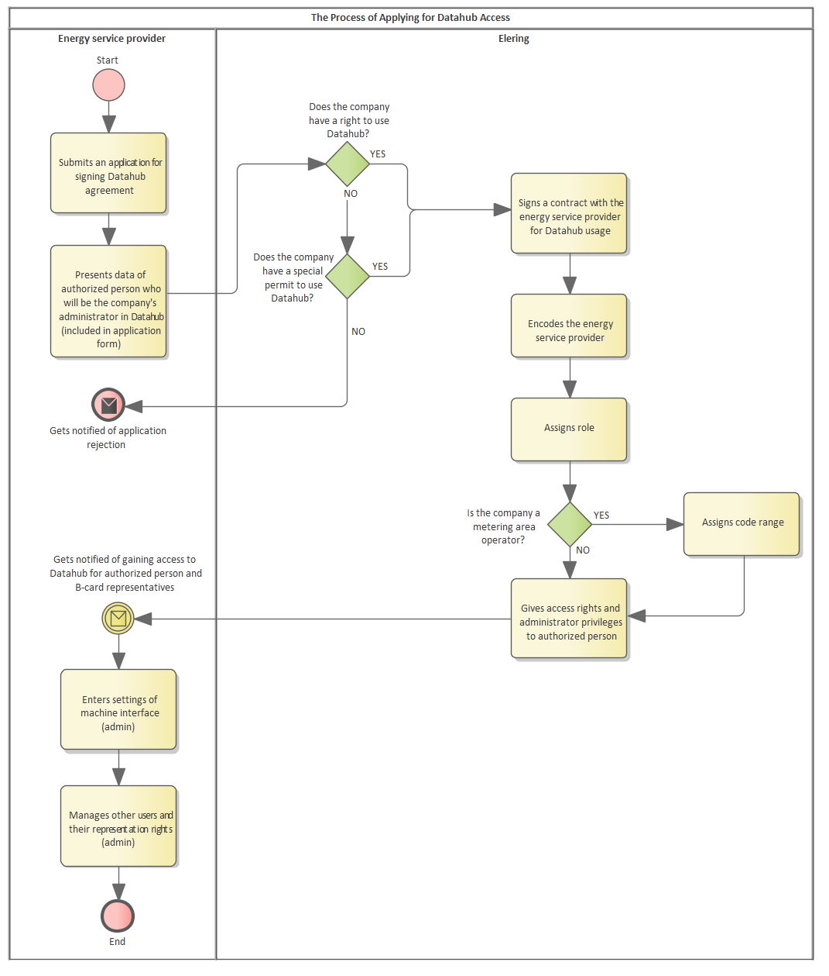
Figure 1. Registration process

Main functionalities of Datahub
The Datahub shall ensure the following main functionalities required for the functioning of the electricity market:
- registration process;
- process for transmitting metering point technical data and metering data;
- process for change of supplier and the messages describing it;
- process for network operators to transmit network invoices;
- channel for exchange of information between open suppliers and network operators;
- administration of uninterrupted chain of open supplies and balance regions;
- 15-minute balance period information exchange;
- calculation and transmission of aggregated summary reports on balance clarifications;
- transmission of aggregate contracts and data for management of DSR data.

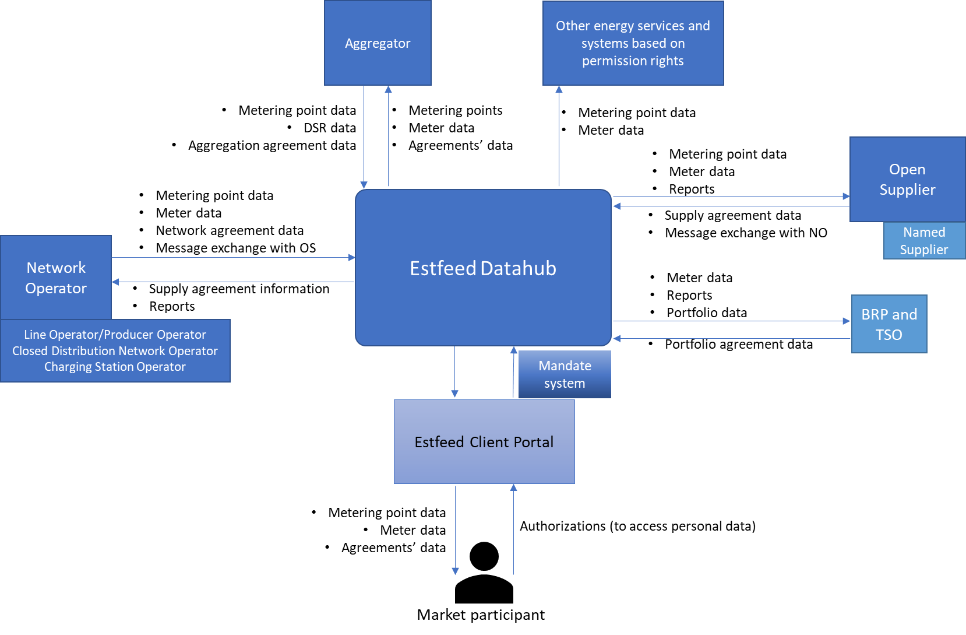

Figure 1. Electricity Datahub main processes

Access rights to information exchange

Information exchange and access of network operators (including line possessors and charging points)
The following information shall be transmitted to the Datahub by a network operator, closed distribution network, line possessor/producer and a charging point operator:

Information to be transmitted | Network operator (GO) | Closed distribution network (ISO) | Line possessor (LO) and producer (PO) | Charging point (CO) | Datahub role | Explanation
Technical information of metering point coded within its own code range and if exists, name and ID of network agreement person and agreement validity dates | YES | YES | YES | YES | Format control, storage, information exchange. Registers the network contract with the client’s EIC (X) code. | Format of technical information. Code range from the Datahub required prior to this.
Hourly metering data by metering points (metering data 15 minutes later) | YES | YES | YES | YES | Format control, storage, information exchange | Obligation on the basis of the network code
Response to open supply agreement change request | YES | YES | NO | NO |  | In case named supplier has not been designated
Contract of supplier designated by network operator (Named supplier agreement) | YES | YES | NO | NO | Storing the contract and ensuring access rights | The designated supplier provides open supply to general service customers on behalf of network operator
Joint invoice agreement with open supplier | YES | YES | NO | NO | Storing the contract and ensuring data exchange | The open supplier submits the network bill to the customer instead of network operator
Joint invoice for customer | YES | YES | NO | NO | Data exchange
Response to disconnection request of joint invoice customer | YES | YES | NO | NO | Data exchange
Response to customer inquiries | YES | YES | NO | NO | Data exchange
Network bill issuance data | YES | YES | NO | NO | Data exchange
Exchange of information with other users | YES | YES | YES | YES | Data exchange | Exchange of information with other users – all or chosen open suppliers, etc.

The access to information by a network operator, closed distribution network, line possessor/producer and a charging point operator shall be as follows:
Access to information | Network operator | Closed distribution network | Line possessor and producer | Charging point | Explanation
Own code range of metering points | YES | YES | YES | YES | For entering metering point information
Data of registered metering points with technical data | YES | YES | YES | YES | Access to the data of its own area
Data of registered metering points’ and information on registered network, supply and aggregation agreements | YES | YES | NO | NO | Access to the data of its own area
Metering data of the metering points | YES | YES | YES | YES | Access to the data of its own area
Metering data of metering points related to itself including border points | YES | YES | YES | YES | Access to data: network operator as a customer
Status of transmission of metering data of own area | YES | YES | YES | YES | New. The Datahub shall monitor data exchange for every metering point
Information on the management of consumption by the aggregator of metering points | YES | YES | YES | YES | New. Basis: network code (currently draft). Access to the data of its own area
Open supply agreement change request data | YES | YES | NO | No | Access to the data of its own area
Registered contracts in own area: joint invoive contract, designated supplier contract, open supplier and balance provider of area | YES | YES | YES | YES | Access to the data of its own area
Data exchange regarding disconnection requests and customer inquiry messages | YES | YES | NO | NO | Access to the data of its own area
Messages related to data exchange | YES | YES | YES | YES | Exchange of information between users
Calculation of network losses | YES | YES | NO | NO | New functionality
Aggregate reports by contracts related to own area | YES | YES | YES | YES | Content of reports described separately

Access to information for open suppliers
An open supplier shall transmit the following information to the Datahub:
Information to be transmitted | Open supplier | Datahub role | Explanation
Open supply contract information by metering point: validity (starting and ending time), charge for premature termination of contract (yes/no). | YES | Customer with a valid open supply contract:  - the Datahub terminates the current open supply contract 14 days in advance (message schedule control), registers the new one and ensures data exchange.  Customer without an open supply contract:  - the Datahub registers the new open supply contract 1 day in advance (message schedule control) and ensures data exchange. | New supplier change process as of 01.01.2023
Open supply portfolio contract with another electricity undertaking: validity (starting and ending time), | YES | Registration of contract. | Registration of contract 7 days in advance
Open supply agreement change request and response to it | YES | Data exchange | Response is given to requests as a BRP/named supplier to network operator
Disconnection request (related to joint invoicing) | YES | Data exchange | Only for own open supply metering points in the network operator’s area with whom joint invoice agreement has been registered
Data related to customer inquiries | YES | Data exchange | Only for own open supply metering points

The access rights of an open supplier to information are as follows:
Access to information | Potential open supplier | Open supplier with a future contract | Open supplier with a valid contract | Open supplier with a contract that expired within a period of up to 12 months | Explanation
Market participant EIC code | YES | YES | YES | YES | Required for registering the open supply contract
List of EIC codes of metering points of market participant along with valid network, open supply and aggregate contracts along with periods of validity | YES | YES | YES | YES | Inspection of validity of contract of open supply of market participant. Purpose: entry into a new open supply contract
Authorisation by market participant for accessing technical information of metering point and metering data of 12 previous months | YES | YES | YES | YES | A market participant can grant authorisation for accessing its data on the basis of the network code
Access to technical information of metering points of market participant | NO | YES | YES | YES | On the basis of an agreement
Access to metering data of 12 months of market participant | NO | NO | YES | YES (data for own open supply period only) | On the basis of an agreement
Metering data of metering point of market participant during period of validity of open supplier contract | NO (no contract) | NO (contract has not entered into force) | YES | YES (data for own open supply period only) | On the basis of an agreement
Aggregator’s DSR metering data | NO | NO | YES | YES | On the basis on and agreement
Contracts of open supplier at metering point(s) of market participant along with validity and party of network and aggregate contract(s) | NO (no contract) | YES | YES | YES | Information on contracts registered by user themselves
Portfolio contracts registered by open supplier | NO (no contract) | YES | YES | YES | Information on contracts registered by user themselves
Portfolio contract information of own open supply | YES | YES | YES | YES | Open suppliers must also have a so-called superior open supplier
Termination of open supply contracts by network operator or another open supplier | NO (no contract) | YES | YES | YES | Information on own contracts
Information on contracts related to being a designated supplier | NO (no contract) | YES | YES | YES | Information on own contracts
Joint invoice agreement with network operator | NO (no contract) | YES | YES | YES | Information on own contracts
Disconnection request data related to joint invoicing | NO (no contract) | NO (contract must be valid for data exchange) | YES | NO | Information on own contracts
Customer inquiry data | NO | NO | YES | YES
Inquiry for preparation of network bill | NO | NO | YES | NO | Information on own contracts
Open supply agreement change request data | NO | YES | YES | YES | Requests by itself and requests where open supplier must reply to requests
Data exchange with another electricity undertaking or Elering | YES | YES | YES | YES | Exchange of information between users
Aggregate reports regarding own area and related contracts | NO | NO | YES | YES up to 3 months | Content of reports described separately.

Access to information for balance providers
A balance provider is an open supplier at a higher hierarchical level that has a balance agreement with Elering. Elering shall enter the information on the balance agreement in the Datahub. In other matters, the rights and obligations of an open supplier shall apply to balance providers.

The imbalance metering points of a balance provider shall be where the balance provider of a market participant and the balance provider of a network operator differs for the respective metering point.
The balance explanation of the inclusion of a metering point of a consumer and/or producer for a balance provider has been determined as follows:
The metering point of the market participant is within the open supply chain of the balance provider | The network operator managing the metering point is within the open supply chain of the balance provider | Inclusion of metering point in the balance explanation of a balance provider  (+) amounts are added at metering point  (-) amounts are subtracted at metering point
Yes | Yes | No
Yes | No | Yes (+)
No | Yes | Yes (-)
No | No | No

The inclusion of a border metering point of a network operator (the point at which electricity from another network operator enters their network) in the balance explanation of a balance provider has been determined as follows:
The network operator is within the open supply chain of the balance provider | The open supplier of the network operator at a higher hierarchical level than the network operator (the person managing their border metering points) is a balance provider | Inclusion of metering point in the balance explanation of a balance provider  (+) amounts are added at metering point  (-) amounts are subtracted at metering point
Yes | Yes | No
Yes | No | Yes (+)
No | Yes | Yes (-)
No | No | No

The access rights of a balance provider to information are as follows:
Access to information | Balance provider with a future contract | Balance provider with a valid contract | Balance provider with a contract that expired within a period of up to 12 months | Datahub role | Explanation
Metering points data of market participants that belong to the balance area: customer’s EIC, metering point EIC, technical data, parties of related contracts, validity (starting and ending time) | YES, during the period of validity of contract | YES, during the period of validity of contract | YES, during the period of validity of contract | Automated open supply chain tree and creation of balance areas | Required for ensuring balance explanation
Metering points of balance provider for network operator excluded from balance area: metering point EIC and network operator | YES, during the period of validity of contract | YES, during the period of validity of contract | YES, during the period of validity of contract
Metering data of market participant’s metering points of that belong to the balance area | YES, during the period of validity of contract | YES, during the period of validity of contract | YES, during the period of validity of contract
Aggregated metering data from metering points of balance provider for network operator excluded from balance area | YES, during the period of validity of contract | YES, during the period of validity of contract | YES, during the period of validity of contract

Access to information for designated (named) suppliers
A designated supplier is a supplier that has a contract with a network operator in their area of activity for the purchase or sale of electricity to market participants without an open supply contract. The network operator shall enter the contractual information in the Datahub. In other matters, the rights and obligations of an open supplier shall apply to balance providers.
Named supplier shall have the same rights regarding the metering point data and metering data as the open supplier with an open supply agreement. The access rights of a designated supplier to information are as follows:
Access to information | Designated supplier with a future contract | Designated supplier with a valid contract | Designated supplier with a contract that expired within a period of up to 12 months | Datahub role | Explanation
Metering points of a market participant that are included in the area of open supply via the designated supplier role: customer’s EIC, metering point EIC, technical data, parties of related contracts, validity (starting and ending time) | YES, during the period of validity of contract | YES, during the period of validity of contract | YES, during the period of validity of contract | Automated administration of open supply chain and data exchange | The role of a designated supplier provides the same rights as an open supplier with a contract
Metering data of metering points of a market participant that are included in the area of open supply via the designated supplier role | YES, during the period of validity of contract | YES, during the period of validity of contract | YES, during the period of validity of contract
Contract information of designated supplier (parties and period of validity) | YES | YES | YES
Aggregate reports to designated supplier | YES, during the period of validity of contract | YES, during the period of validity of contract | YES, during the period of validity of contract
All other accesses and messages of open supplier during the validity of open supply contract | YES, during the period of validity of contract | YES, during the period of validity of contract | YES, during the period of validity of contract

Access to information for aggregators
An aggregator shall transmit the following information to the Datahub:
Information to be transmitted | Aggregator | Datahub role | Explanation
Aggregate contract information by network contract metering point: validity (starting and ending time) | YES | The basis for registration of new aggregate contracts is that the market participant does not have a valid aggregate contract in the Datahub that is at valid at least 14 days in advance | Aggregators register and finish the information of their contracts by themselves
Technical information of metering point coded within its own code range | YES | Recording of technical information of metering point | Aggregator’s metering points
Hourly metering data by metering point (metering data 15 minutes later) | YES | Recording of information and data exchange | Transmission of consumption management information by metering point of network contract

The access rights of an aggregator to information are as follows:
Access to information | Potential aggregator | Aggregator with a future contract | Aggregator with a valid contract | Aggregator with a contract that expired within a period of up to 12 months | Explanation
Market participant EIC code | YES on the basis of authorisation | YES | YES | YES | Required for registering the aggregate contract
List of EIC codes of metering points of market participant along with valid network and aggregate contracts along with periods of validity | YES on the basis of authorisation | YES | YES | YES | Inspection of validity of network contract of market participant. Purpose: entry into a new aggregate contract
Authorisation by market participant for accessing technical information of metering point and metering data of 12 previous months | YES | YES | YES | YES | A market participant can grant authorisation for accessing its data on the basis of the network code
Access to technical information of metering points of market participant | NO | YES | YES | YES | On the basis of an agreement
Access to metering data of 12 months of market participant | NO | NO | NO | NO | Authorisation required
Metering data of metering point of market participant during period of validity of aggregator contract | NO (no contract) | NO (contract has not entered into force) | YES | YES (data for own period of contract) | On the basis of an agreement
Contracts of aggregator at metering point(s) of market participant along with validity and party of network and open supply contract | NO (no contract) | YES | YES | YES | Information on contracts registered by user themselves
Aggregator metering points data | YES | YES | YES | YES | Data registered by aggregator itself
Portfolio contract information of own open supply | YES | YES | YES | YES | Aggregators must also have a so-called superior open supplier
Terminations of aggregate contracts by network operator as of termination of contract | NO (no contract) | YES | YES | YES | Information on own contracts
Data exchange with another electricity undertaking or Elering | YES | YES | YES | YES | Exchange of information between users
Aggregate reports regarding own area and related contracts | NO | NO | YES | YES up to 3 months | Content of reports described separately

Access to information for energy services
The authorisation of the market participant shall serve as the basis for accessing the data on other energy services. Energy services shall not transmit information to the Datahub themselves.
Access to information | Energy service | Explanation
Market participant EIC code | YES on the basis of authorisation | Authorisation by customer required
Authorisation by market participant for accessing technical information of metering point and metering data of 12 previous months | YES | Transmission of authorisation of market participant
Access to technical information of metering points of market participant | YES on the basis of authorisation | Authorisation by customer required
Access to metering data of market participant for 12 months or another period pursuant to authorisation | YES on the basis of authorisation | Authorisation by customer required

Access to information for system operator (balance management and renewable energy business process)
    - Data exchange of balance management business process
The system operator shall gain access to the balance explanation on metering points, metering data and aggregate reports for every balance provider regarding their respective balance area.
    - Data exchange of renewable energy business process
The system operator is entitled to gain access to the technical information and metering data of every metering point producing energy and registered in the renewable energy information system.

Notification system
The objective of the notification system is to allow electricity undertakings and Elering to send internal notifications to other users of the Datahub. The functionality allows for sending text-based notifications to the target group chosen by the user.
Via the notification system, Elering is able to:
- send notifications to everyone (system maintenance, upgrades and other general information important for operators);
- send role-based notifications to electricity undertakings (e.g. only network operators or network operators along with open suppliers and other combinations);
- send automatic reminders to network operators (private notifications) who have failed to submit metering data in a timely manner.
Via the notification system, electricity undertakings are able to:
- send notifications to all Datahub users;
- send role-based notifications to electricity undertakings (e.g. only network operators or network operators along with open suppliers and other combinations);
- send notifications to electricity undertakings related to their portfolio contract (undertaking higher in the supply chain sends information to another one lower in the chain);
- send notifications only to specific registered undertakings (private notices);
- send notifications only to Elering.
Users are able to redirect system notifications to the e-mail address included in their contact details. Users are also able to remove such redirection by themselves.

